Test Case: tc001_SPX_Dev5_Crear_Solicitud_Articulo_Almacen
Step 1 - Enter username and password and click to button Enter : Credentials Entered
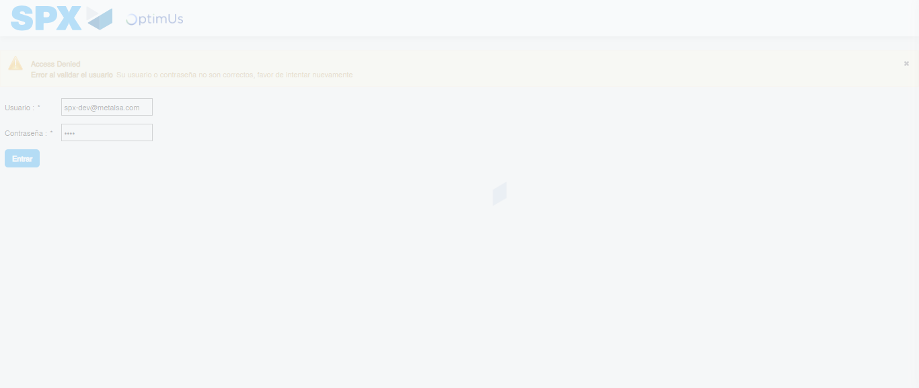Image file-name: QC_Testing-tc001_SPX_Dev5_Crear_Solicitud_Articulo_Almacen-1787845270538

Step 2 - Select to UEN and Access to Request for a New Inventory Item : UEN Correctly selected and Correct access
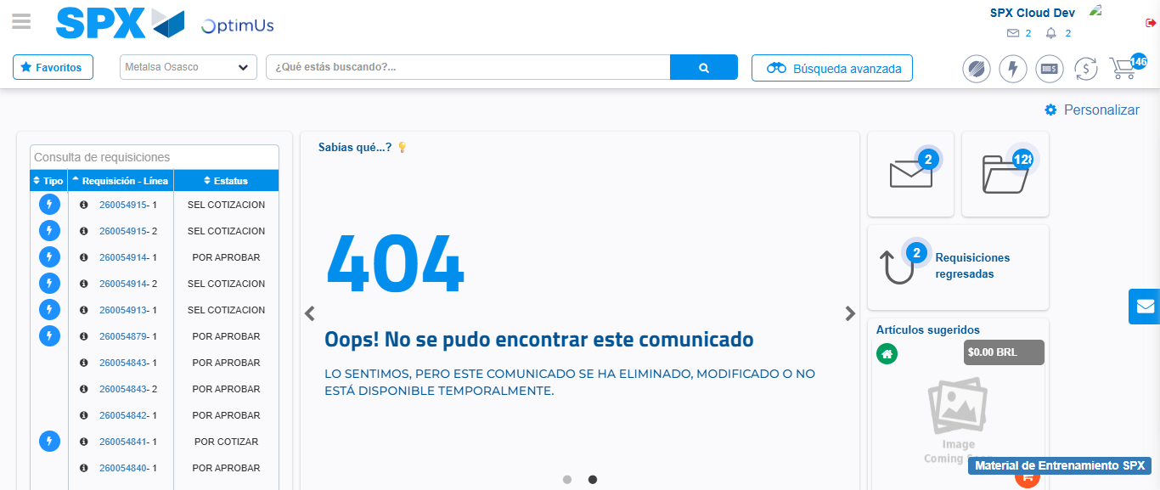Image file-name: QC_Testing-tc001_SPX_Dev5_Crear_Solicitud_Articulo_Almacen-1787845340138

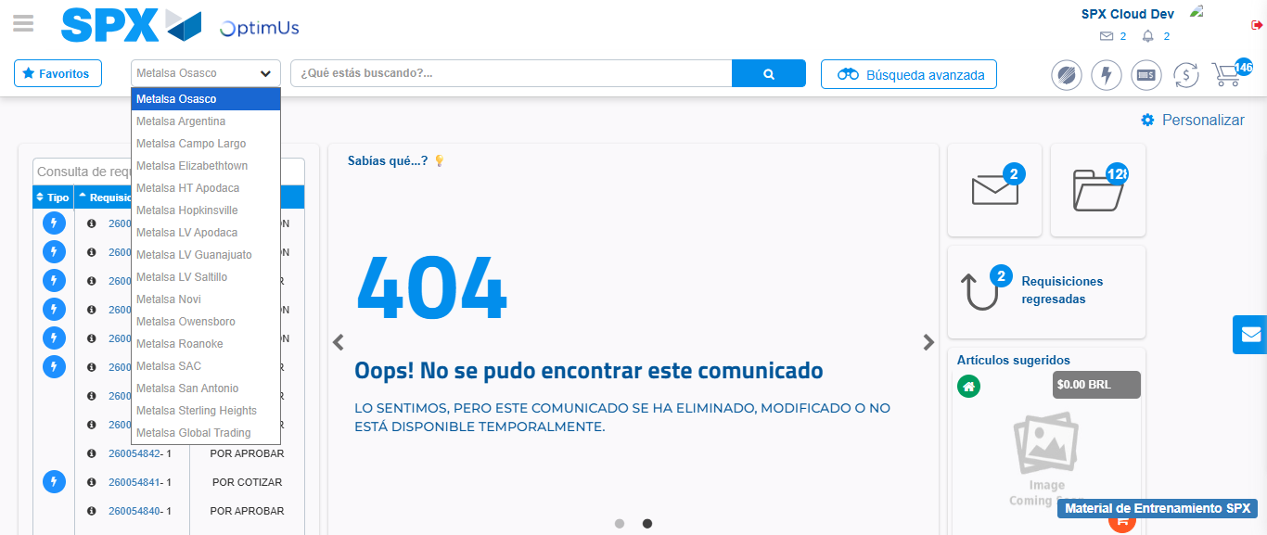Image file-name: QC_Testing-tc001_SPX_Dev5_Crear_Solicitud_Articulo_Almacen-1787845340773

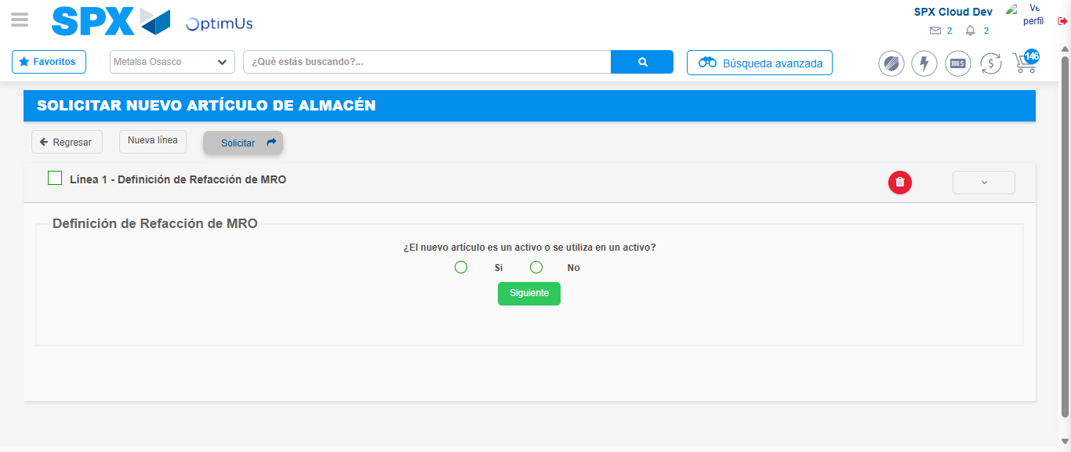Image file-name: QC_Testing-tc001_SPX_Dev5_Crear_Solicitud_Articulo_Almacen-1787845345981

Step 3 - Select options first section : Options seleted correctly
Image file-name: QC_Testing-tc001_SPX_Dev5_Crear_Solicitud_Articulo_Almacen-1787845346277

Image file-name: QC_Testing-tc001_SPX_Dev5_Crear_Solicitud_Articulo_Almacen-1787845346432

Step 7 - Return to Main Page SPX : Return to Main Page SPX
Image file-name: QC_Testing-tc001_SPX_Dev5_Crear_Solicitud_Articulo_Almacen-1787845340138

Image file-name: QC_Testing-tc001_SPX_Dev5_Crear_Solicitud_Articulo_Almacen-1787845340773

Image file-name: QC_Testing-tc001_SPX_Dev5_Crear_Solicitud_Articulo_Almacen-1787845345981

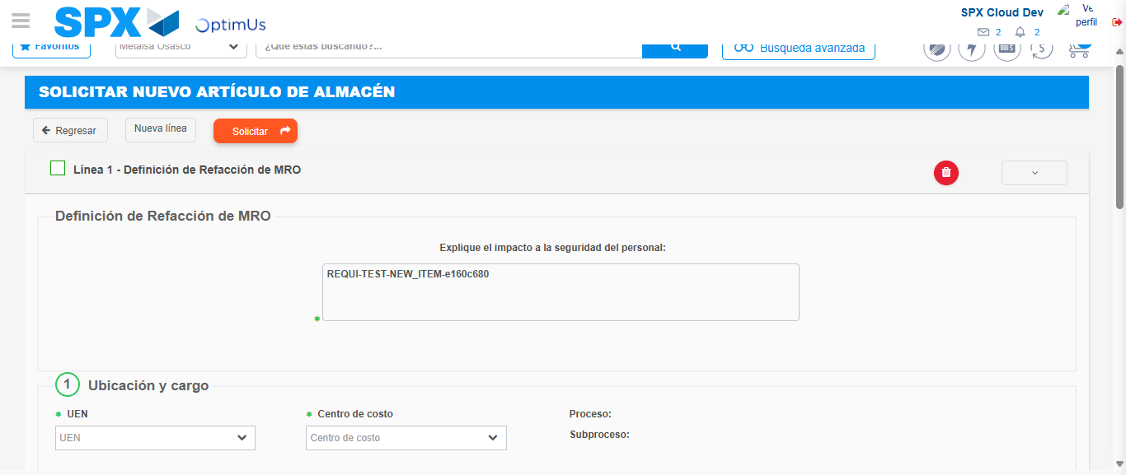Image file-name: QC_Testing-tc001_SPX_Dev5_Crear_Solicitud_Articulo_Almacen-1787845354604

Image file-name: QC_Testing-tc001_SPX_Dev5_Crear_Solicitud_Articulo_Almacen-1787845354781

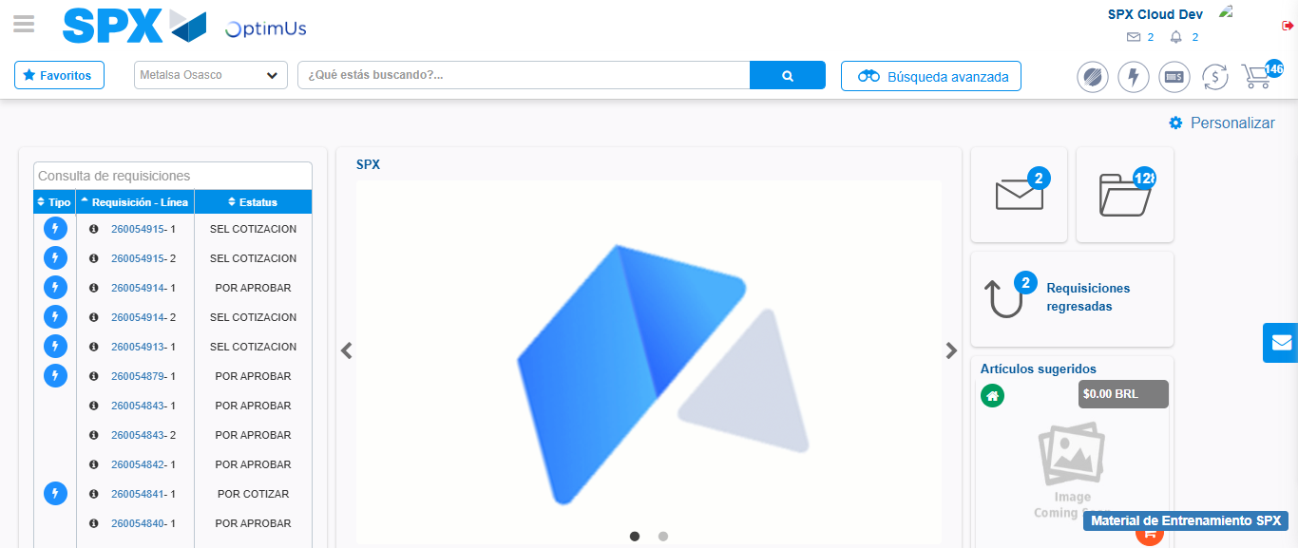Image file-name: QC_Testing-tc001_SPX_Dev5_Crear_Solicitud_Articulo_Almacen-1787845375929

Step 8 - Log Out : Log Out SPX
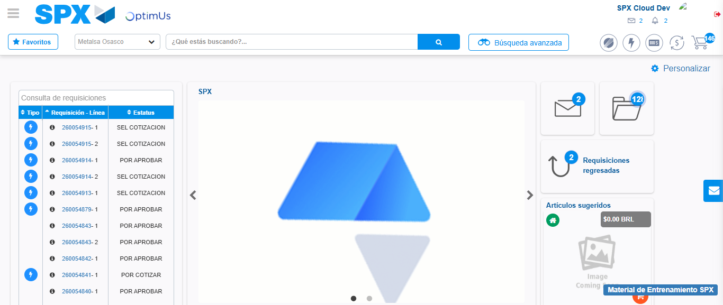Image file-name: QC_Testing-tc001_SPX_Dev5_Crear_Solicitud_Articulo_Almacen-1787845376236

